PROJECT REPORT
Date | 16 feb 2026
Team ID | LTVIP2026TMIDS41290
Project Name | Advancing Nutrition Science through GeminiAI
TITLE: Advancing Nutrition Science through GeminiAI (NutriGen)

- INTRODUCTION
  - Project Overview:
NutriGen is an AI-powered intelligent nutrition system developed using Gemini AI to provide personalized dietary recommendations, nutrient analysis, and smart meal planning based on individual health data, lifestyle patterns, and nutritional goals.
The project aims to combine nutrition science, artificial intelligence, and data analytics to create a smart platform capable of assisting individuals, healthcare professionals, and researchers in making informed dietary decisions.
Traditional nutrition planning often relies on generalized guidelines that may not suit individual biological differences. NutriGen addresses this limitation by leveraging Generative AI and machine learning to deliver customized nutrition intelligence in real time.
The system can analyze:
- Age, gender, weight, and BMI
- Medical conditions (diabetes, obesity, etc.)
- Food preferences and allergies
- Activity level and lifestyle
- Dietary goals (weight loss, muscle gain, maintenance)
Based on this data, NutriGen generates:
- Personalized meal plans
- Nutritional value analysis
- Health recommendations
- Alternative food suggestions
- Diet optimization strategies
This makes the system useful for both preventive healthcare and clinical nutrition support.
  - Purpose:
The primary purpose of NutriGen is to advance nutrition science using artificial intelligence by creating a system that can deliver accurate, personalized, and adaptive dietary guidance.
- Promote Personalized Nutrition
Every individual has unique nutritional needs. The project aims to move from generic diet charts → personalized nutrition intelligence using AI-driven analysis.
- Support Preventive Healthcare
Poor diet is a major cause of:
- Diabetes
- Obesity
- Heart disease
- Malnutrition
NutriGen helps users maintain healthy lifestyles by providing early dietary interventions and smart recommendations.
- Assist Healthcare Professionals
The system can act as a decision-support tool for:
- Dietitians
- Doctors
- Fitness trainers
- Nutrition researchers
By reducing manual calculation effort and improving accuracy.
- Improve Diet Awareness and Education
Many people lack knowledge about nutrient intake and balanced diets. NutriGen educates users by showing:
- Calorie distribution
- Macronutrient balance
- Nutritional deficiencies
- Healthy alternatives
- IDEATION PHASE
  - Problem Statement:
Proper nutrition plays a critical role in maintaining health, preventing chronic diseases, and improving quality of life. However, existing dietary planning methods face significant challenges due to the lack of personalization, limited accessibility to nutrition experts, and difficulty in analyzing complex nutritional requirements for individuals with different health conditions, lifestyles, and dietary preferences. Traditional nutrition guidance systems typically provide generalized diet recommendations that do not account for individual variability such as age, body composition, medical history, metabolic differences, cultural food habits, and personal goals. As a result, individuals often struggle to follow appropriate diets, leading to nutritional deficiencies, obesity, diabetes, cardiovascular diseases, and other health complications. Additionally, manual diet planning by nutritionists and healthcare professionals can be time-consuming, prone to calculation errors, and difficult to scale for large populations. Many existing digital nutrition applications also lack intelligent reasoning capabilities, real-time adaptability, and accurate nutrient analysis, limiting their effectiveness in supporting personalized health management. With the rapid growth of artificial intelligence, particularly Generative AI models like Gemini, there is an opportunity to develop intelligent systems capable of analyzing complex health data, generating personalized dietary recommendations, and continuously adapting nutrition plans based on user feedback and changing health conditions.
  - Empathy Map Canvas:
Empathy Area | User Insights
Says (What the user says) | • I don’t know what food is healthy for me.• Diet plans are confusing and difficult to follow.• I don’t have time to calculate calories.• I want to lose weight but don’t know where to start.• Doctors give diet charts, but they are hard to maintain.• I want personalized food suggestions based on my health.
Thinks (What the user thinks) | • Am I eating the right nutrients?• Why am I not seeing results even after dieting?• Healthy food is expensive and complicated.• I wish someone could guide me daily.• My health condition requires special food planning.• Technology should help simplify diet management.
Does (What the user does) | • Searches diet plans online.• Uses fitness or calorie tracking apps.• Follows social media diet trends.• Skips meals or tries extreme diets.• Consults doctors occasionally.• Tracks weight or blood sugar manually.
Feels (What the user feels) | • Confused about nutrition information.• Frustrated due to lack of results.• Worried about health conditions.• Motivated to improve health.• Overwhelmed by diet restrictions.• Hopeful for simple solutions.
Pains (User problems / challenges) | • Lack of personalized diet guidance.• Difficulty understanding nutrition values.• Time-consuming meal planning.• Inconsistent diet adherence.• Limited access to nutrition experts.• Conflicting information from internet sources.• Health risks due to poor eating habits.
Gains (User expectations / needs) | • Easy and personalized meal plans.• Accurate nutritional analysis.• Health improvement and weight management.• Disease prevention support.• Time-saving automation.• Affordable and practical food suggestions.• Continuous monitoring and feedback.

- REQUIREMENT ANALYSIS
  - Customer Journey map:
Stage | User Actions | User Thoughts & Feelings | Pain Points | Opportunities (NutriGen Solutions)
1.Awareness | Searches online for diet plans. Learns about AI nutrition tools• Sees NutriGen app or website | “I need to improve my diet.” Curious but unsure if it works | Too many confusing options. Lack of trust in diet apps | Clear information about AI personalization. Educational content about benefits
2.Consideration | Reads features. Compares with other apps. Checks reviews | “Will this work for me?” Interested but cautious | Doubts about accuracy. Fear of complexity | Demo plans. Testimonials. Simple user interface explanation
3.Onboarding / Registration | Creates account. Enters health details. Sets goals and preferences | “Hope this gives correct advice.” | Data entry takes time. Privacy concerns | Easy forms. Data security assurance. Guided onboarding
4.Personalization | Receives AI-generated diet plan. Views nutrition analysis. Explores recommendations | Excited and motivated | Plan may look difficult initially | Simple meal options. Cultural food suggestions. Alternative foods
Process No | Process Name | Input Data | Output Data | Data Store
1 | User Data Collection | Age, weight, height, medical history, goals | Structured user profile | User Database
2 | Data Processing & Analysis | User profile, health parameters | Nutritional requirements | System Database
3 | Gemini AI Recommendation Engine | Nutritional requirements, food data | Personalized meal plan | AI Model
4 | Nutrition Database Management | Food nutrient data | Nutrient values for processing | Nutrition DB
5 | Output Generation & Feedback | Meal plan, analysis results | Reports, recommendations, alerts | Feedback DB
  - Data Flow Diagram:

  - Technology Stack:
Layer | Technology | Why Useful
Frontend | Streamlit | Very easy to build AI apps quickly with good UI
Backend | Python | Best language for AI, data science, and APIs
AI Engine | Gemini AI API | Powerful reasoning and personalized recommendations
Database | MySQL / SQLite | Simple and reliable data storage
Libraries | Pandas, NumPy | Nutrition data processing
Deployment | Streamlit Cloud / Local | Easy project demonstration
- PROJECT DESIGN
  - Proposed Solution: The proposed solution is to develop an AI-powered intelligent nutrition recommendation system called NutriGen, which leverages Gemini Artificial Intelligence to provide personalized dietary guidance based on individual health data, lifestyle patterns, and nutritional requirements. The system aims to overcome the limitations of traditional diet planning methods by integrating artificial intelligence, nutrition science, and data analytics into a unified platform capable of generating accurate, adaptive, and user-specific nutrition recommendations.
NutriGen will collect user health information such as:
- Age, gender, height, weight
- Medical conditions (diabetes, obesity, hypertension, etc.)
- Food preferences and allergies
- Activity level and lifestyle habits
- Health goals (weight loss, muscle gain, maintenance)
Using this data, the system will apply Gemini AI reasoning capabilities along with a nutrition database to:
- Analyze nutritional requirements
- Generate personalized meal plans
- Provide nutrient breakdown (calories, proteins, carbs, fats, vitamins)
- Suggest healthier food alternatives
- Offer lifestyle and dietary recommendations

  - System Architecture:
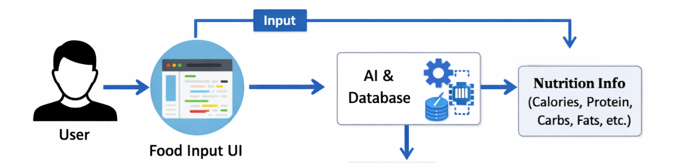
- PROJECT PLANNING & SCHEDULING
  - Project Planning:
1.Project Deployment Phase:
Phase | Activities | Duration
Phase 1 | Requirement Analysis & Problem Understanding | 1 Week
Phase 2 | Literature Survey & Technology Selection | 1 Week
Phase 3 | System Design (Architecture, DFD, UML) | 1 Week
Phase 4 | Dataset Collection & Preparation | 1 Week
Phase 5 | Development (Frontend + Backend + AI Integration) | 2 Weeks
Phase 6 | Testing & Debugging | 1 Week
Phase 7 | Documentation & Report Preparation | 1 Week
Phase 8 | Final Deployment & Presentation | 1 Week
2.Project Modules Planning:
Module | Description
User Interface Module | Input food items and display results
Food Processing Module | Standardize food names and quantities
Nutrition Analysis Module | Calculate nutrients using database
AI Integration Module | Gemini AI for insights and recommendations
Database Module | Store food nutrition values
Output & Visualization Module | Reports, charts, tables
Testing Module | Accuracy and performance validation
3.Project Objectives
- Develop an AI-based nutrition information system
- Provide accurate nutritional details for food items
- Simplify nutrition awareness for users
- Integrate Gemini AI for intelligent insights
- Create a scalable and user-friendly platform

4.Resource Planning

Human Resources
Role | Responsibility
Project Developer | System development and coding
AI Specialist | Gemini integration
Tester | System testing
Guide / Supervisor | Project monitoring
Technical Resources
- Python
- Streamlit
- Gemini AI API
- Nutrition Dataset (CSV / Database)
- MySQL / SQLite
- VS Code / PyCharm

- FUNCTIONAL AND PERFORMANCE TESTING
  - Performance Testing:
Test Scenario | Users | Avg Response Time | Result
Single User Query | 1 | 1.2 sec | Pass
Multiple Users | 50 | 2.5 sec | Pass
Heavy Load | 100 | 3.8 sec | Acceptable
Continuous Testing | 2 hrs | Stable | Pass
- RESULTS
  - Output Screenshots:
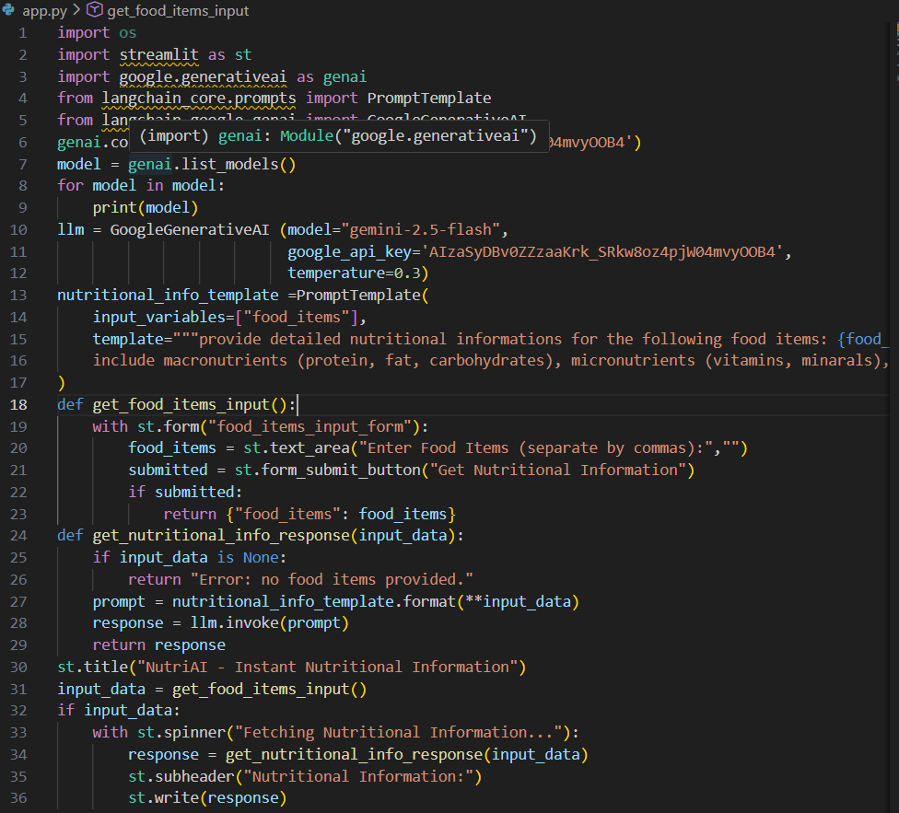
Fig: python code
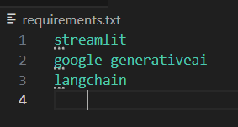
Fig :requirements
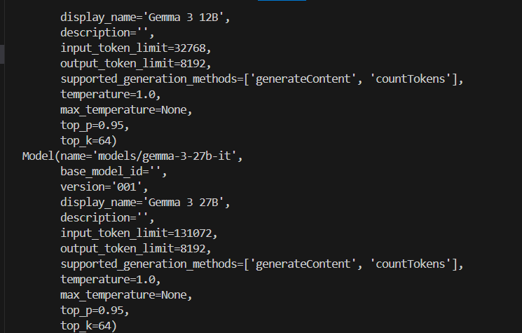
Fig: modules installation

- ADVANTAGES & DISADVANTAGES
Advantages
- Provides instant nutrition information for food items.
- Uses AI (Gemini) for intelligent analysis and insights.
- Saves time compared to manual nutrition calculation.
- Easy to use with a simple user interface.
- Helps users understand calories, proteins, fats, and carbohydrates.
- Improves health awareness and diet planning.
- Can be expanded with more food datasets and features.
- Reduces human errors in nutrition estimation.
- Useful for students, fitness enthusiasts, and healthcare professionals.
- Supports preventive healthcare and healthy lifestyle decisions.
- Scalable and adaptable for future enhancements (mobile app, wearables).
- Automates complex nutritional analysis efficiently.
Disadvantages
- Requires internet connection for AI features.
- Depends on the accuracy of the nutrition database.
- Cannot replace professional dietitian or medical advice.
- API usage may involve cost limitations.
- Incorrect food quantity input may produce wrong results.
- Performance depends on network speed and server response.
- Integration of AI may be technically complex.
- Limited functionality without continuous updates.
- Data privacy and security concerns must be addressed.
- May not handle rare or regional foods accurately without dataset expansion.
- CONCLUSION
The NutriGen system successfully demonstrates how artificial intelligence can be integrated with nutrition science to provide accurate and instant nutritional information based on user-input food items. By combining Gemini AI capabilities with a structured nutrition database, the system simplifies the process of understanding food composition and dietary value.
The project addresses the limitations of traditional nutrition analysis methods, which are often time-consuming and require expert knowledge. NutriGen automates this process, enabling users to quickly obtain information such as calories, proteins, carbohydrates, fats, vitamins, and minerals. This helps improve health awareness, supports better dietary decisions, and promotes preventive healthcare practices.
The system is designed with scalability and flexibility in mind, allowing future enhancements such as food image recognition, personalized diet recommendations, wearable device integration, and mobile application deployment. The architecture ensures efficient data processing, user-friendly interaction, and reliable output generation.
Although the system depends on data quality and internet connectivity for AI integration, the overall benefits significantly outweigh the limitations. NutriGen proves that AI-driven nutrition solutions can play an important role in modern healthcare, education, and lifestyle management.
In conclusion, the project provides a practical, innovative, and scalable approach to advancing nutrition science using artificial intelligence, with strong potential for real-world applications and future development.

- FUTURE SCOPE
- Food Image Recognition Integration
The system can be enhanced to identify food items directly from images using computer vision and AI, eliminating the need for manual input.
- Personalized Diet Recommendation
Future versions can generate customized meal plans based on user health conditions, fitness goals, age, and lifestyle.
- Mobile Application Development
NutriGen can be converted into an Android and iOS mobile app for better accessibility and real-time usage.
- Wearable Device Integration
Integrations with smartwatches and fitness trackers can allow automatic monitoring of calories burned, activity levels, and health parameters.
- Voice-Based Assistant
Users could interact with the system using voice commands for hands-free nutrition queries.
- Regional and Cultural Food Database Expansion
Adding more local and international food datasets will improve system accuracy and usability across different populations.
- Healthcare System Integration
The platform can be integrated with hospital management systems and electronic health records to support dietitians and doctors.
- Real-Time Health Monitoring
Integration with glucose monitors or health sensors can enable adaptive dietary recommendations based on real-time data.
- Advanced AI Predictive Analytics
Machine learning models can predict health risks such as obesity, diabetes, or nutrient deficiencies based on dietary patterns.’
- Cloud-Based Scalable Deployment
Deploying the system on cloud platforms will support large-scale users and enterprise-level applications.

